

**PUBLIC   
DISCLOSURE STATEMENT**

kiNG & wOOD MALLESONS

Organisation CERTIFICATION

FY2022-23 (true up)

Australian Government

**Climate Active   
Public Disclosure Statement**



|  |  |  |
| --- | --- | --- |
| NAME OF CERTIFIED ENTITY | V Ajuja & Others trading as King & Wood Mallesons |  |
| REPORTING PERIOD | 1 July 2022 – 30 June 2023  [True-up] |  |
| DECLARATION | *To the best of my knowledge, the information provided in this public disclosure statement is true and correct and meets the requirements  of the Climate Active Carbon Neutral Standard.* |  |
| Susan Kitchener  Climate Change & Environment Lead  26 October 2023 |  |

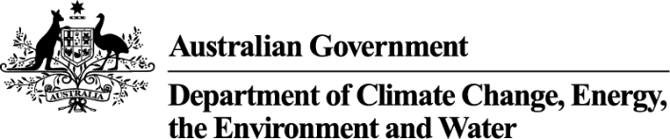

Public Disclosure Statement documents are prepared by the submitting organisation. The material in the Public Disclosure Statement document represents the views of the organisation and do not necessarily reflect the views of the Commonwealth. The Commonwealth does not guarantee the accuracy of the contents of the Public Disclosure Statement document and disclaims liability for any loss arising from the use of the document for any purpose.

Version August 2023.

# Certification summary

|  |  |
| --- | --- |
| TOTAL EMISSIONS OFFSET | 9,857 tCO2-e |
| OFFSETS USED | 7.8% ACCUs  92.2% VCUs |
| RENEWABLE ELECTRICITY | 0% Tenancy  87% Base building |
| CARBON ACCOUNT | Prepared by: King & Wood Mallesons |
| TECHNICAL ASSESSMENT | Next technical assessment due: FY 2025 |

Contents

1. Certification summary 3

2. Carbon neutral information 4

3. Emissions boundary 6

4. Emissions reductions 8

5. Emissions summary 9

6. Carbon offsets 11

7. Renewable Energy Certificate (REC) Summary 14

Appendix A: Additional Information 15

Appendix B: Electricity summary 19

Appendix C: Inside emissions boundary 24

Appendix D: Outside emissions boundary 26

# Carbon neutral information

### Description of certification

The certification covers the period 1 July 2022 to 30 June 2023, and is a true up of emissions projected using actual data for the period 1 July 2021 to 30 June 2022. From FY24 all certifications will be in arrears rather than in advance, therefore no further true ups will be required.

The emissions inventory in this public disclosure summary covers the actual emissions from 1 July 2022 to 30 June 2023, and has been developed in accordance with the Climate Active Carbon Neutral Standard for Organisations. The boundary has been defined based on the operational control approach.

The certification covers the operational emissions of King & Wood Mallesons Australia, comprising the Australian partnership of King & Wood Mallesons (ABN 22 041 424 954) and its associated entity Dabserv Pty Ltd (ACN 008 511 993).

KWM’s Australian business is conducted primarily through these two “entities”:

* the Australian Partnership: provides our legal services to our clients; and
* Dabserv Pty Limited: provides various support services (such as premises, finance, technology, travel, people & development and business development services) to the Australian partnership

collectively called “KWM Australia”. Each entity has its own employees and suppliers. For convenience, any reference to KWM Australia refers collectively to both entities unless otherwise specified.

### Organisation description

KWM Australia is a full-service commercial law firm delivering a range of transactional and disputes based legal services and capability. We have market leading legal expertise in climate and ESG, cross-border mergers and acquisitions; private equity; public M&A; employment; intellectual property; competition; international funds; commercial litigation; international arbitration; projects, energy and resources; real estate; construction; environment; tax; banking and finance; and restructuring and insolvency.

Our core business function involves the delivery of specialist professional legal services to our clients.

We advise and support our clients, both domestically and internationally on complex Australian law matters across a range of sectors. KWM Australia is part of King & Wood Mallesons, a global law firm headquartered in Asia, with offices in 28 locations around the world. Legal services are provided independently by each of the separate King & Wood Mallesons member firms.

While KWM Australia’s operations are predominantly based in Australia, as a member of the King & Wood Mallesons global network, KWM Australia has relationships with other members of that network which have operations outside Australia, as part of the pursuit of a common global strategy. The members of the network trade under a common name to provide seamless multi-jurisdictional legal services to the world’s leading commercial and other entities, however emissions generated by any members of the network outside of Australia are not included in this certification. While our relationship with members within the King & Wood Mallesons global network is very important to KWM Australia and our clients, we do not control the foreign business operations of these independent member firms of King & Wood Mallesons.

The boundary for this inventory includes the following locations:

Sydney office 1 Farrer Pl

Melbourne office 447 Collins St

Brisbane office Waterfront Place

Perth office QV1

Canberra Office Constitution Place

The certification covers the operational emissions of King & Wood Mallesons Australia, comprising the Australian partnership of King & Wood Mallesons (ABN 22 041 424 954) and its associated entity Dabserv Pty Ltd (ACN 008 511 993). The boundary has been defined based on the operational control approach.

# Emissions boundary

### Inside the emissions boundary

All emission sources listed in the emissions boundary are part of the carbon neutral claim.

**Quantified emissions** have been assessed as relevant and are quantified in the carbon inventory. This may include emissions that are not identified as arising due to the operations of the certified entity, however are **optionally included**.

**Non-quantified emissions** have been assessed as relevant and are captured within the emissions boundary, but are not measured (quantified) in the carbon inventory. All material emissions are accounted for through an uplift factor. Further detail is available at Appendix C.

### Outside the emissions boundary

**Excluded emissions** are those that have been assessed as not relevant to an organisation’s operations and are outside of its emissions boundary or are outside of the scope of the certification. These emissions are not part of the carbon neutral claim. Further detail is available at Appendix D.

**Outside emission boundary**

**Excluded**

Nil

**Quantified**

* Stationary energy and fuels
* Electricity
* Accommodation
* Carbon neutral products and services
* Cleaning and chemicals
* Food
* ICT services and equipment
* Professional services
* Office equipment and supplies
* Postage, courier and freight
* Refrigerants
* Transport (air)
* Transport (land and sea)
* Waste
* Water
* Working from home
* Products
* Machinery and vehicles

**Non-quantified**

Nil

**Inside emissions boundary**

**Optionally included**

Nil

# Emissions reductions

### Emissions reduction strategy

KWM’s board-approved Climate Change and Sustainability Strategy makes the following commitments to emissions reductions:

* Use 100% renewable electricity in all our Australian tenancies from January 2024, representing a reduction of around 30% of KWM’s footprint based on FY19 (base year) levels, and a 100% reduction of scope 2 emissions. (Contracts signed for purchase of GreenPower)
* Set science-based targets by December 2023 and reach net zero emissions by 2050
* KWM has signed the SBTi commitment letter and confirmation of this can be found by [visiting the SBTi website](https://sciencebasedtargets.org/companies-taking-action), scrolling down to the Target Dashboard and searching for “Mallesons”
* In line with SBTi requirements our net zero target requires elimination of all abatable emissions with no more than 10% of “hard to abate” emissions being offset via a carbon sink
* Our interim target has not yet been set but will represent at least a 50% reduction across all scopes from FY19 levels by 2030
* KWM’s next PDS (for our FY24 certification) will contain further details of these targets and strategy for their achievement.

KWM’s Environmental Management System contains a number of shorter-term time-bound objectives and targets focussed on reducing emissions including the below, which are all slated for completion by FY24 and will reduce the firm’s scope 3 emissions:

* Update to travel policy (including flights and accommodation) to reduce quantity and carbon intensity of flights and capitalize on the reduction in travel necessitated by Covid
* Business travel behaviour change campaign
* Implementation of a sustainable procurement policy, which will include minimum energy ratings for purchases and preferencing of suppliers who are addressing their own emissions
* Print minimisation initiative including physical removal of some MFPs (complete) and a behaviour change campaign to reduce the need to print

### Emissions reduction actions

* We again offered our people the opportunity to reduce their emissions at home with subsidised renewable energy. via Iberdrola’s “Green the Team” scheme. 48 team members signed up for a total of 186MWh of clean energy.
* The hospitality team has further “Ditched the Disposable” with 99% of all single use items now replaced by re-usable alternatives.
* We have installed Purezza water systems in all centres and no longer use or sell bottled water.
* Stationery re-use and recycling was made available in all centres; staff can drop re-usable items in caddies and drop off any items that are beyond re-use in recycling boxes.
* Organics recycling is now available and underdesk bins have been removed in favour of centralised waste collection in all tenancies.

# Emissions summary

### Emissions over time

|  |  |  |  |
| --- | --- | --- | --- |
| **Emissions since base year** | | | |
|  |  | Total tCO2-e (without uplift) | Total tCO2-e (with uplift) |
| Base year: | 2018-19 | 19,826 | N/A |
| Year 1: | 2021-22 | 7,410 | N/A |
| Year 2: | 2022-23 | 9,857 | N/A |

### Significant changes in emissions

Employee commute emissions decreased due to a more accurate calculation provided via a staff survey, rather than relying on ABS data to estimate.

|  |  |  |  |
| --- | --- | --- | --- |
| Emission source name | Previous year emissions (t CO2-e) | Current year emissions (t CO2-e) | Detailed reason for change |
| Long business class flights (>3,700km) | 417 | 1,603 | Return to flying post-Covid and increase due to pent up demand |
| Short economy class flights (>400km, ≤3,700km) | 233 | 1,043 |

### Use of Climate Active carbon neutral products, services, buildings or precincts

|  |  |
| --- | --- |
| Certified brand name | Product/Service/Building/Precinct used |
| Telstra | Mobile phone plans |
| Australia Post | Local and overseas parcels |
| Four Pillars | Alcohol (not deducted from inventory as not possible to isolate total) |
| Pangolin Associates | Consulting services |
| Opal Australian Paper | Paper |
| QV1 Perth | Building |
| 477 Collins St, Melbourne | Building |

### Emissions summary

The previous report was a projection report using representative data to estimate the emissions for the reporting year. This table shows the differences between the projected emissions and the actual emissions recorded.

|  |  |  |  |  |  |
| --- | --- | --- | --- | --- | --- |
| **Emission category** | **Projected emissions (tCO2-e)** | **Sum of scope 1 (tCO2-e)** | **Sum of scope 2 (tCO2-e)** | **Sum of scope 3 (tCO2-e)** | **Sum of total emissions (t CO2-e)** |
| Accommodation and facilities | 90.75 | 0.00 | 0.00 | 275.19 | 275.19 |
| Cleaning and chemicals | 119.38 | 0.00 | 0.00 | 126.68 | 126.68 |
| Climate Active carbon neutral products and services | 0.00 | 0.00 | 0.00 | 0.00 | 0.00 |
| Electricity | 1,538.24 | 0.00 | 1404.32 | 382.67 | 1786.99 |
| Food | 946.51 | 0.00 | 0.00 | 1084.26 | 1084.26 |
| ICT services and equipment | 1,725.26 | 0.00 | 0.00 | 850.99 | 850.99 |
| Machinery and vehicles | 2.15 | 0.00 | 0.00 | 3.21 | 3.21 |
| Office equipment and supplies | 331.86 | 0.00 | 0.00 | 687.89 | 687.89 |
| Postage, courier and freight | 193.24 | 0.00 | 0.00 | 69.36 | 69.36 |
| Products | 1.33 | 0.00 | 0.00 | 2.49 | 2.49 |
| Professional services | 277.83 | 0.00 | 0.00 | 561.34 | 561.34 |
| Refrigerants | 22.55 | 21.53 | 0.00 | 0.00 | 21.53 |
| Stationary energy (gaseous fuels) | 217.89 | 21.77 | 0.00 | 42.82 | 64.59 |
| Transport (air) | 784.00 | 0.00 | 0.00 | 3293.97 | 3293.97 |
| Transport (land and sea) | 1,967.77 | 0.00 | 0.00 | 687.97 | 687.97 |
| Waste | 30.38 | 0.00 | 0.00 | 54.05 | 54.05 |
| Water | 4.89 | 0.00 | 0.00 | 14.80 | 14.80 |
| Working from home | -844.08 | 0.00 | 0.00 | 270.90 | 270.90 |
| **Total emissions** | **9089.95** | **43.30** | **1404.32** | **8408.59** | **9856.21** |
| **Difference between projected and actual emissions** | **Projected minus actual = 767 tCO2-e** | | | | |

### Uplift factors

N/A.

# Carbon offsets

### Offsets retirement approach

The total emission to offset is 9,857 t CO­­2-e. The total number of eligible offsets used in this report is 9857. Of the total eligible offsets used, 9090 were previously banked and 767 were newly purchased and retired. 0 are remaining and have been banked for future use.

### Co-benefits

**Economic**

Revenue from the sale of credits is reinvested in managing country, supporting jobs and training for landowners and custodians, and connecting people back to country.

**Social & Cultural**

The employment of old and young people is facilitating reconnection with cultural values, including language, and protection of important cultural sites.

Jawoyn also conduct annual bushwalks and canoe trips in the cool early dry season, when the nights are dewy and it’s the right time to burn. These cross-country events involve rangers and family groups moving through country as the old people did, burning as they go. Bushwalks have become an annual feature of Jawoyn’s fire management program and are eagerly anticipated by rangers and their families.

Integrating fire management with such cultural activities delivers positive co-benefits for Jawoyn people. Participating in early dry season burning enables Jawoyn people young and old to be meaningfully involved in the management of their customary estates and conducting cultural maintenance activities in tandem with other fire management activities, brings greater cultural and social benefits to the community.

**Environmental**

Currently, fires across northern Australia produce around 3 percent of our national greenhouse gas emissions, but [account for approximately 40 per cent](https://www.cleanenergyregulator.gov.au/Infohub/Media-Centre/Resources/erf-media-resources/traditional-methods-used-to-combat-climate-change) of the Northern Territory's total emission profile. Over the past decade, fire management has transformed the patterns of fire across Jawoyn land. The reduction in late dry season wildfire helps protect small patches of sensitive vegetation communities, significant fire sensitive ecosystems, and the many threatened species in the region. As a result, important birds, mammals and reptiles are returning to country.

The project supports the following SDGs

13 – Climate Action

8 – Decent work and economic growth

15 – Life on Land

### Eligible offsets retirement summary

|  |  |  |  |  |  |  |  |  |  |  |  |  |  |  |
| --- | --- | --- | --- | --- | --- | --- | --- | --- | --- | --- | --- | --- | --- | --- |
| **Offsets retired for Climate Active carbon neutral certification** | | | | | | | | | | | | |  | |
| **Project description** | | Type of offset units | Registry | Date retired | Serial number (and hyperlink to registry transaction record) | Vintage | Stapled quantity | Eligible quantity retired (tCO2-e) | Eligible quantity used for previous reporting periods | Eligible quantity banked for future reporting periods | Eligible quantity used for this reporting period (FY23 true up) | Percentage of total (%) | |
| Nyaliga Fire Project  Savanna Fire Management | | ACCU | ANREU | 30/6/22 | 8,331,543,849-8,331,545,848 | CP2 |  | 2000 | 2000 | 0 | 0 | 0% | |
| Haikou Rural Methane Digesters Project in Hainan Province | | VER | Impact Registry | 21/7/22 | [GS1-1-CN-GS2664-4-2017-21433-21992-24991](https://registry.goldstandard.org/credit-blocks/details/282305) | 2017 |  | 3000 | 3000 | 0 | 0 | 0% | |
| Chongqing Longshui 8MW Hydro Power Project | | VCU | Verra | 15/7/22 | [11128-283150760-283154659-VCS-VCU-291-VER-CN-1-667-01012014-31122014-0](https://registry.verra.org/myModule/rpt/myrpt.asp?r=206&h=165064) | 2014 |  | 3900 | 2410 | 0 | 1490 | 15.11% | |
| 1.6 MW Bundled Rice Husk Based Cogeneration Plant by M/s Milk food Limited (MFL) in Patiala (Punjab) & Moradabad (U.P) Districts | | VCU | Verra | 5/8/22 | [10168-190818158-190819849-VCS-VCU-291-VER-IN-1-784-01012018-31122018-0](https://registry.verra.org/myModule/rpt/myrpt.asp?r=206&h=154719) | 2018 |  | 1682 | 0 | 0 | 1692 | 17.16% | |
| 1.6 MW Bundled Rice Husk Based Cogeneration Plant by M/s Milk food Limited (MFL) in Patiala (Punjab) & Moradabad (U.P) Districts | | VCU | Verra | 5/8/22 | [10168-190819850-190821957-VCS-VCU-291-VER-IN-1-784-01012018-31122018-0](https://registry.verra.org/myModule/rpt/myrpt.asp?r=206&h=175022) | 2018 |  | 2108 | 0 | 0 | 2108 | 21.38% | |
| Wind bundle project in Maharashtra by Sispara | | VCU | Verra | 25/10/22 | [8457-21896701-21900500-VCS-VCU-997-VER-IN-1-1660-01012019-31102019-0](https://registry.verra.org/myModule/rpt/myrpt.asp?r=206&h=177403) | 2019 |  | 3800 | 0 | 0 | 3800 | 38.55% | |
| Jawoyn Fire 2, Savannah burning | | ACCU | ANREU | 3/11/23 | 8,330,519,066 - 8,330,519,832 | 2021-2022 | 0 | 767 | 0 | 0 | 767 | 7.80% | |
|  | **Total eligible offsets retired and used for this report** | | | | | | | | | | 9,857 |  | |
|  | **Total eligible offsets retired this report and banked for use in future reports** | | | | | | | | | 0 |  |  | |

|  |  |  |
| --- | --- | --- |
| **Type of offset units** | **Eligible quantity (used for this reporting period)** | **Percentage of total** |
| Australian Carbon Credit Units (ACCUs) | 767 | 7.80% |
| VCUs (Verified Carbon Units) | 9090 | 92.2% |

# 7. Renewable Energy Certificate (REC) Summary

### Renewable Energy Certificate (REC) summary

N/A.

# Appendix A: Additional Information

**FY22 Organisation certification – error in data for tenancy electricity**

During the third-party verification of KWM’s FY23 Climate Active service certification (projection based on FY22 actual organisation emissions) it was noted that an error had been made in the calculation of electricity usage for both Sydney and Brisbane tenancies. This was due to:

* Brisbane – a misunderstanding of the electricity billing provided by the building manager and missing invoices
* Sydney – incorrect billing by the retailer, requiring the reversal and re-issue of several bills

This did not affect the subsequent FY23 Organisation and Service certifications as a true-up has been performed as noted in this PDS. However this error meant that the emissions for FY22’s Climate Active Organisation certification were incorrect. Even though the difference in use and emissions was immaterial relative to the size of the footprint, in the interests of full transparency KWM wishes to disclose the error here and has purchased an additional 16 ACCUs to cover the 16tCO2-2 emitted from the use of an extra 3,228kWh used in Brisbane and 16,491kWh used in Sydney. The emissions calculation is provided as part of Electricity Summary in Appendix B.

|  |  |  |  |  |  |  |  |
| --- | --- | --- | --- | --- | --- | --- | --- |
| **Additional offsets retired for purposes other than Climate Active carbon neutral certification** | | | | | | | |
| Project description | **Type of offset units** | **Registry** | **Date retired** | **Serial number (and hyperlink to registry transaction record)** | **Vintage** | **Eligible Quantity (tCO2-e)** | **Purpose of retirement** |
| Jawoyn Fire 2, Savannah burning | ACCU | ANREU | 3/11/23 | 8,330,519,050 - 8,330,519,065 | 2021-2022 | 16 | FY22 Climate Active Carbon Neutral Organisation certification – extra electricity use |

### ACCU retirement confirmations

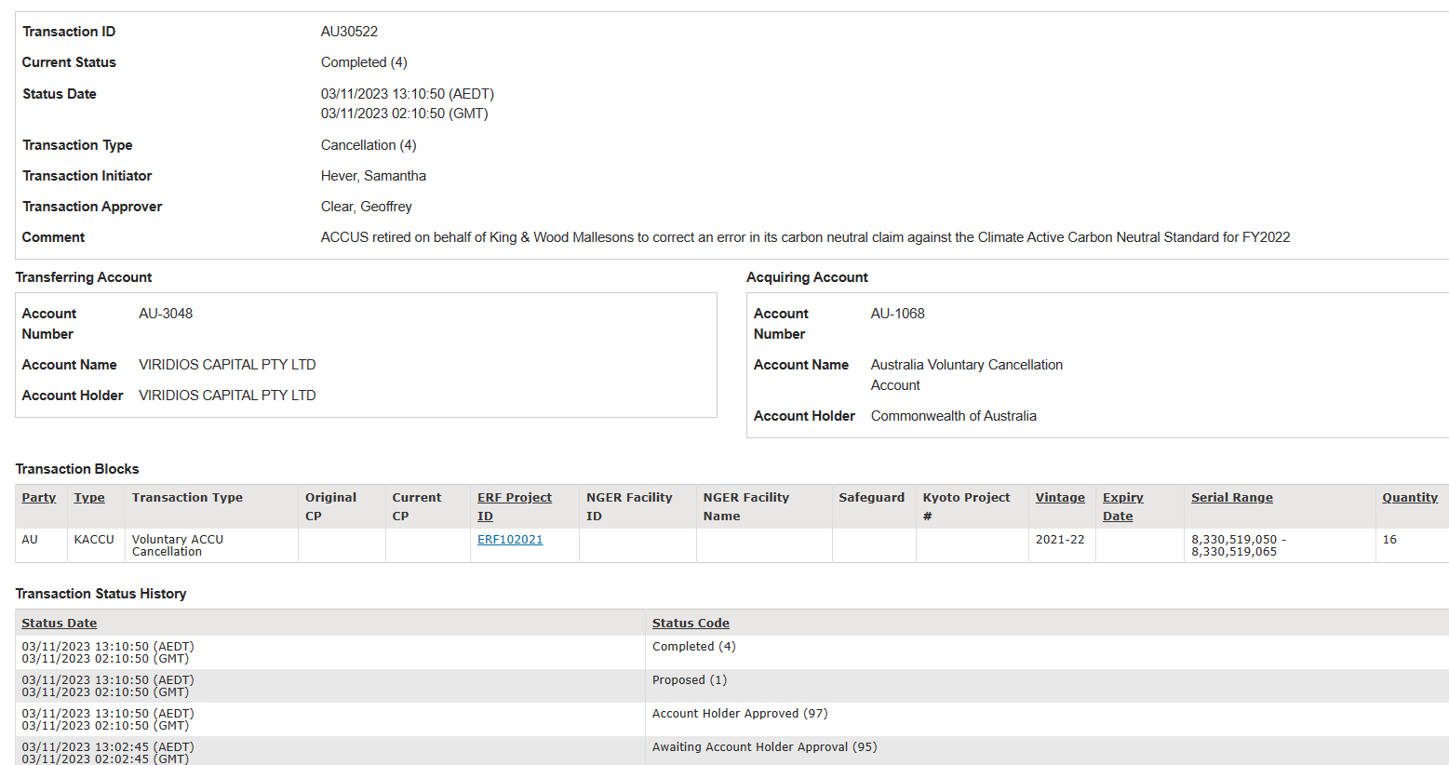

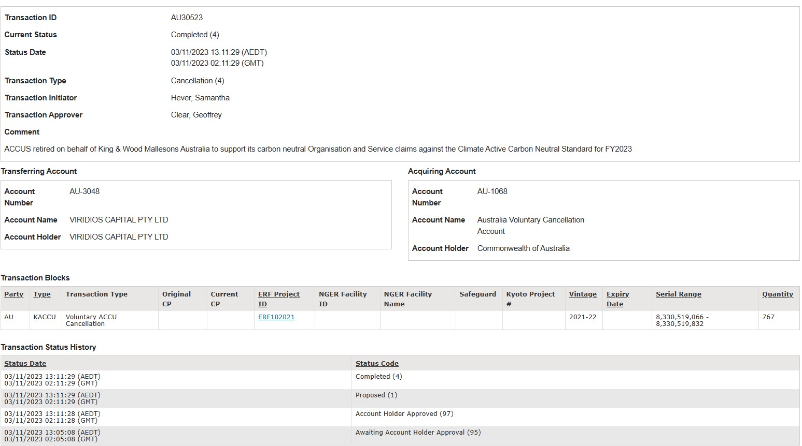





# Appendix B: Electricity summary

There are two international best-practice methods for calculating electricity emissions – the location-based method and the market-based method. Reporting electricity emissions under both methods is called dual reporting.

Dual reporting of electricity emissions is useful, as it provides different perspectives of the emissions associated with a business’s electricity usage.

Location-based method:

The location-based method provides a picture of a business’s electricity emissions in the context of its location, and the emissions intensity of the electricity grid it relies on. It reflects the average emissions intensity of the electricity grid in the location (State) in which energy consumption occurs. The location-based method does not allow for any claims of renewable electricity from grid-imported electricity usage.

Market-based method:

The market-based method provides a picture of a business’s electricity emissions in the context of its renewable energy investments. It reflects the emissions intensity of different electricity products, markets and investments. It uses a residual mix factor (RMF) to allow for unique claims on the zero emissions attribute of renewables without double-counting.

For this certification, electricity emissions have been set by using the **market-based approach**.

|  |  |  |  |
| --- | --- | --- | --- |
| Market-based approach summary |  |  |  |
| **Market-based approach** | **Activity Data (kWh)** | **Emissions  (kg CO2-e)** | **Renewable percentage of total** |
| Behind the meter consumption of electricity generated | 0 | 0 | 0% |
| **Total non-grid electricity** | **0** | **0** | **0%** |
| LGC Purchased and retired (kWh) (including PPAs) | 0 | 0 | 0% |
| GreenPower | 0 | 0 | 0% |
| Climate Active precinct/building (voluntary renewables) | 0 | 0 | 0% |
| Precinct/Building (LRET) | 0 | 0 | 0% |
| Precinct/Building jurisdictional renewables (LGCS surrendered) | 0 | 0 | 0% |
| Electricity products (voluntary renewables) | 0 | 0 | 0% |
| Electricity products (LRET) | 0 | 0 | 0% |
| Electricity products jurisdictional renewables (LGCs surrendered) | 0 | 0 | 0% |
| Jurisdictional renewables (LGCs surrendered) | 93,121 | 0 | 4% |
| Jurisdictional renewables (LRET) (applied to ACT grid electricity) | 23,616 | 0 | 1% |
| Large Scale Renewable Energy Target (applied to grid electricity only) | 383,464 | 0 | 18% |
| Residual Electricity | 1,665,120 | 1,590,189 | 0% |
| **Total renewable electricity (grid + non grid)** | **500,202** | **0** | **23%** |
| **Total grid electricity** | **2,165,321** | **1,590,189** | **23%** |
| **Total electricity (grid + non grid)** | **2,165,321** | **1,590,189** | **23%** |
| Percentage of residual electricity consumption under operational control | 100% |  |  |
| **Residual electricity consumption under operational control** | **1,665,120** | **1,590,189** |  |
| Scope 2 | 1,470,495 | 1,404,323 |  |
| Scope 3 (includes T&D emissions from consumption under operational control) | 194,624 | 185,866 |  |
| **Residual electricity consumption not under operational control** | **0** | **0** |  |
| Scope 3 | 0 | 0 | . |

**Tenancy Electricity**

Tenancy and base building electricity are represented in separate tables so that the scope 2 and 3 division is accurate.

|  |  |
| --- | --- |
| **Total renewables (grid and non-grid)** | **23.10%** |
| **Mandatory** | **18.80%** |
| **Voluntary** | **4.30%** |
| **Behind the meter** | **0.00%** |
| **Residual scope 2 emissions (t CO2-e)** | **1,404.32** |
| **Residual scope 3 emissions (t CO2-e)** | **185.87** |
| **Scope 2 emissions liability (adjusted for already offset carbon neutral electricity) (t CO2-e)** | **1,404.32** |
| **Scope 3 emissions liability (adjusted for already offset carbon neutral electricity) (t CO2-e)** | **185.87** |
| **Total emissions liability (t CO2-e)** | **1,590.19** |
| *Figures may not sum due to rounding. Renewable percentage can be above 100%* |  |

|  |  |  |  |  |  |  |
| --- | --- | --- | --- | --- | --- | --- |
| Location-based approach summary | | | | | | |
| **Location-based approach** | **Activity Data (kWh) total** | **Under operational control** | | | **Not under operational control** | |
| **Percentage of grid electricity consumption under operational control** | **100%** | **(kWh)** | **Scope 2 Emissions (kgCO2-e)** | **Scope 3 Emissions (kgCO2-e)** | **(kWh)** | **Scope 3 Emissions (kgCO2-e)** |
| ACT | 125,619 | 125,619 | 91,702 | 7,537 | 0 | 0 |
| NSW | 1,020,580 | 1,020,580 | 745,024 | 61,235 | 0 | 0 |
| SA | 0 | 0 | 0 | 0 | 0 | 0 |
| VIC | 482,586 | 482,586 | 410,198 | 33,781 | 0 | 0 |
| QLD | 291,706 | 291,706 | 212,945 | 43,756 | 0 | 0 |
| NT | 0 | 0 | 0 | 0 | 0 | 0 |
| WA | 244,830 | 244,830 | 124,863 | 9,793 | 0 | 0 |
| TAS | 0 | 0 | 0 | 0 | 0 | 0 |
| **Grid electricity (scope 2 and 3)** | **2,165,321** | **2,165,321** | **1,584,732** | **156,102** | **0** | **0** |
| ACT | 0 | 0 | 0 | 0 |  |  |
| NSW | 0 | 0 | 0 | 0 |  |  |
| SA | 0 | 0 | 0 | 0 |  |  |
| VIC | 0 | 0 | 0 | 0 |  |  |
| QLD | 0 | 0 | 0 | 0 |  |  |
| NT | 0 | 0 | 0 | 0 |  |  |
| WA | 0 | 0 | 0 | 0 |  |  |
| TAS | 0 | 0 | 0 | 0 |  |  |
| **Non-grid electricity (behind the meter)** | **0** | **0** | **0** | **0** |  |  |
| **Total electricity (grid + non grid)** | **2,165,321** |  |  |  |  |  |

|  |  |
| --- | --- |
| **Residual scope 2 emissions (t CO2-e)** | **1,584.73** |
| **Residual scope 3 emissions (t CO2-e)** | **156.10** |
| **Scope 2 emissions liability (adjusted for already offset carbon neutral electricity) (t CO2-e)** | **1,584.73** |
| **Scope 3 emissions liability (adjusted for already offset carbon neutral electricity) (t CO2-e)** | **156.10** |
| **Total emissions liability** | **1,740.83** |

|  |  |  |  |
| --- | --- | --- | --- |
| Market-based approach summary |  |  |  |
| **Market-based approach** | **Activity Data (kWh)** | **Emissions  (kg CO2-e)** | **Renewable percentage of total** |
| Behind the meter consumption of electricity generated | 12,594 | 0 | 1% |
| **Total non-grid electricity** | **12,594** | **0** | **1%** |
| LGC Purchased and retired (kWh) (including PPAs) | 1,041,608 | 0 | 66% |
| GreenPower | 0 | 0 | 0% |
| Climate Active precinct/building (voluntary renewables) | 0 | 0 | 0% |
| Precinct/Building (LRET) | 0 | 0 | 0% |
| Precinct/Building jurisdictional renewables (LGCS surrendered) | 0 | 0 | 0% |
| Electricity products (voluntary renewables) | 0 | 0 | 0% |
| Electricity products (LRET) | 0 | 0 | 0% |
| Electricity products jurisdictional renewables (LGCs surrendered) | 0 | 0 | 0% |
| Jurisdictional renewables (LGCs surrendered) | 29,504 | 0 | 2% |
| Jurisdictional renewables (LRET) (applied to ACT grid electricity) | 7,482 | 0 | 0% |
| Large Scale Renewable Energy Target (applied to grid electricity only) | 288,220 | 0 | 18% |
| Residual Electricity | 206,073 | 196,800 | 0% |
| **Total renewable electricity (grid + non grid)** | **1,379,408** | **0** | **87%** |
| **Total grid electricity** | **1,572,887** | **196,800** | **86%** |
| **Total electricity (grid + non grid)** | **1,585,481** | **196,800** | **87%** |
| Percentage of residual electricity consumption under operational control | 0% |  |  |
| **Residual electricity consumption under operational control** | **0** | **0** |  |
| Scope 2 | 0 | 0 |  |
| Scope 3 (includes T&D emissions from consumption under operational control) | 0 | 0 |  |
| **Residual electricity consumption not under operational control** | **206,073** | **196,800** |  |
| Scope 3 | 206,073 | 196,800 |  |

**Base building Electricity**

Tenancy and base building electricity are represented in separate tables so that the scope 2 and 3 division is accurate.

|  |  |
| --- | --- |
| **Total renewables (grid and non-grid)** | **87.00%** |
| **Mandatory** | **18.65%** |
| **Voluntary** | **67.56%** |
| **Behind the meter** | **0.79%** |
| **Residual scope 2 emissions (t CO2-e)** | **0.00** |
| **Residual scope 3 emissions (t CO2-e)** | **196.80** |
| **Scope 2 emissions liability (adjusted for already offset carbon neutral electricity) (t CO2-e)** | **0.00** |
| **Scope 3 emissions liability (adjusted for already offset carbon neutral electricity) (t CO2-e)** | **196.80** |
| **Total emissions liability (t CO2-e)** | **196.80** |
| *Figures may not sum due to rounding. Renewable percentage can be above 100%* |  |

|  |  |  |  |  |  |  |  |
| --- | --- | --- | --- | --- | --- | --- | --- |
| Location-based approach summary | | | | | | | |
| **Location-based approach** | **Activity Data (kWh) total** | **Under operational control** | | | **Not under operational control** | | |
| **Percentage of grid electricity consumption under operational control** | **0%** | **(kWh)** | **Scope 2 Emissions (kgCO2-e)** | **Scope 3 Emissions (kgCO2-e)** | **(kWh)** | | **Scope 3 Emissions (kgCO2-e)** |
| ACT | 39,800 | 0 | 0 | 0 | 39,800 | | 31,442 |
| NSW | 822,160 | 0 | 0 | 0 | 822,160 | | 649,507 |
| SA | 0 | 0 | 0 | 0 | 0 | | 0 |
| VIC | 194,955 | 0 | 0 | 0 | 194,955 | | 179,358 |
| QLD | 268,186 | 0 | 0 | 0 | 268,186 | | 236,004 |
| NT | 0 | 0 | 0 | 0 | 0 | | 0 |
| WA | 247,786 | 0 | 0 | 0 | 247,786 | | 136,283 |
| TAS | 0 | 0 | 0 | 0 | 0 | | 0 |
| **Grid electricity (scope 2 and 3)** | **1,572,887** | **0** | **0** | **0** | **1,572,887** | | **1,232,593** |
| ACT | 12,594 | 12,594 | 0 | 0 |  | |  |
| NSW | 0 | 0 | 0 | 0 |  | |  |
| SA | 0 | 0 | 0 | 0 |  | |  |
| VIC | 0 | 0 | 0 | 0 |  | |  |
| QLD | 0 | 0 | 0 | 0 |  | |  |
| NT | 0 | 0 | 0 | 0 |  | |  |
| WA | 0 | 0 | 0 | 0 |  | |  |
| TAS | 0 | 0 | 0 | 0 |  | |  |
| **Non-grid electricity (behind the meter)** | **12,594** | **12,594** | **0** | **0** |  | |  |
| **Total electricity (grid + non grid)** | **1,585,481** |  |  |  |  | |  |
| **Residual scope 2 emissions (t CO2-e)** | | | | | | **0.00** | |
| **Residual scope 3 emissions (t CO2-e)** | | | | | | **1,232.59** | |
| **Scope 2 emissions liability (adjusted for already offset carbon neutral electricity) (t CO2-e)** | | | | | | **0.00** | |
| **Scope 3 emissions liability (adjusted for already offset carbon neutral electricity) (t CO2-e)** | | | | | | **1,232.59** | |
| **Total emissions liability** | | | | | | **1,232.59** | |

**Additional information - FY22 certification – error in data for tenancy electricity**

KWM has purchased an additional 16 ACCUs to cover the 16tCO2-2 emitted from the use of an extra 3,228kWh used in Brisbane and 16,491kWh used in Sydney. The emissions calculation was performed using the same Climate Active Electricity calculator (v7) as was used for the original certification. The resulting market based approach summary appears below.



# Appendix C: Inside emissions boundary

### Non-quantified emission source.

There are no non-quantified sources in the emission boundary.

### Data management plan for non-quantified sources

There are no non-quantified sources in the emission boundary that require a data management plan.

# Appendix D: Outside emissions boundary

### Excluded emission sources

No emission sources were assessed as “not relevant” to our organisation’s operations and therefore outside the emissions boundary.

Emission sources considered for relevance must be included within the certification boundary if they meet two of the five relevance criteria. Those which only meet one condition of the relevance test can be excluded from the certification boundary.

Emissions tested for relevance are detailed below against each of the following criteria:

1. **Size** The emissions from a particular source are likely to be large relative to the organisation’s or electricity, stationary energy and fuel emissions.
2. **Influence** The responsible entity has the potential to influence the reduction of emissions from a particular source.
3. **Risk** The emissions from a particular source contribute to the organisation’s greenhouse gas risk exposure.
4. **Stakeholders** Key stakeholders deem the emissions from a particular source are relevant.
5. **Outsourcing** The emissions are from outsourced activities previously undertaken within the organisation’s boundary, or from outsourced activities typically undertaken within the boundary for comparable organisations.

### Excluded emissions sources summary

N/A

